OBSERVATIONS:

As logging has proceeded a systematic method of vein description has been developed on-site, veins are broadly of 4 categories:

Barren Qtz,

Barren Carbonate,

Qtz with sulphides

Carbonate with sulfides

these four types can be further subdivided, see vein descriptions below:

**VEIN SPECIES**

**QTZ VEINS :**

VSM: Veins with sulphides in the middle, Pyrite and / or Pyrrotite, +_ cp

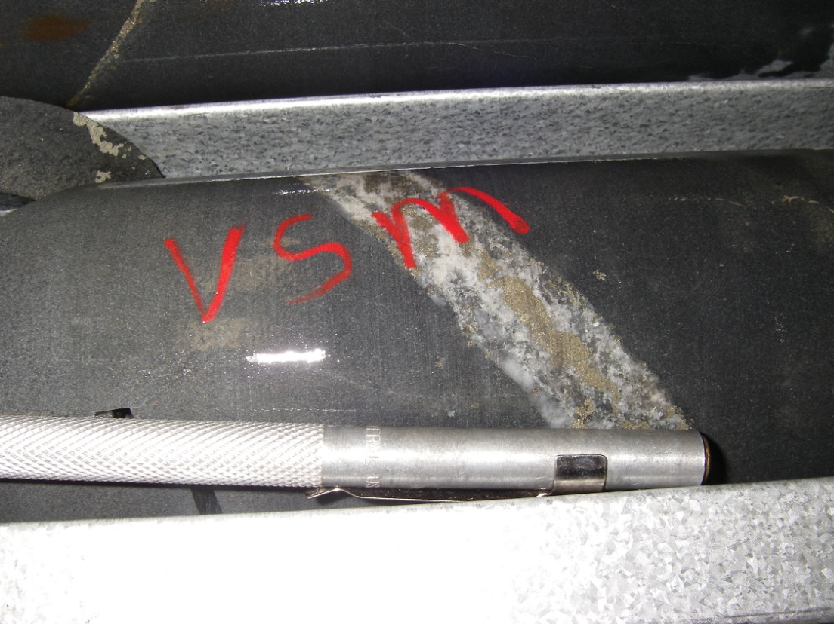

VSE: Veins with sulphide on the edge, Pyrite and / or Pyrrotite, +_ cp

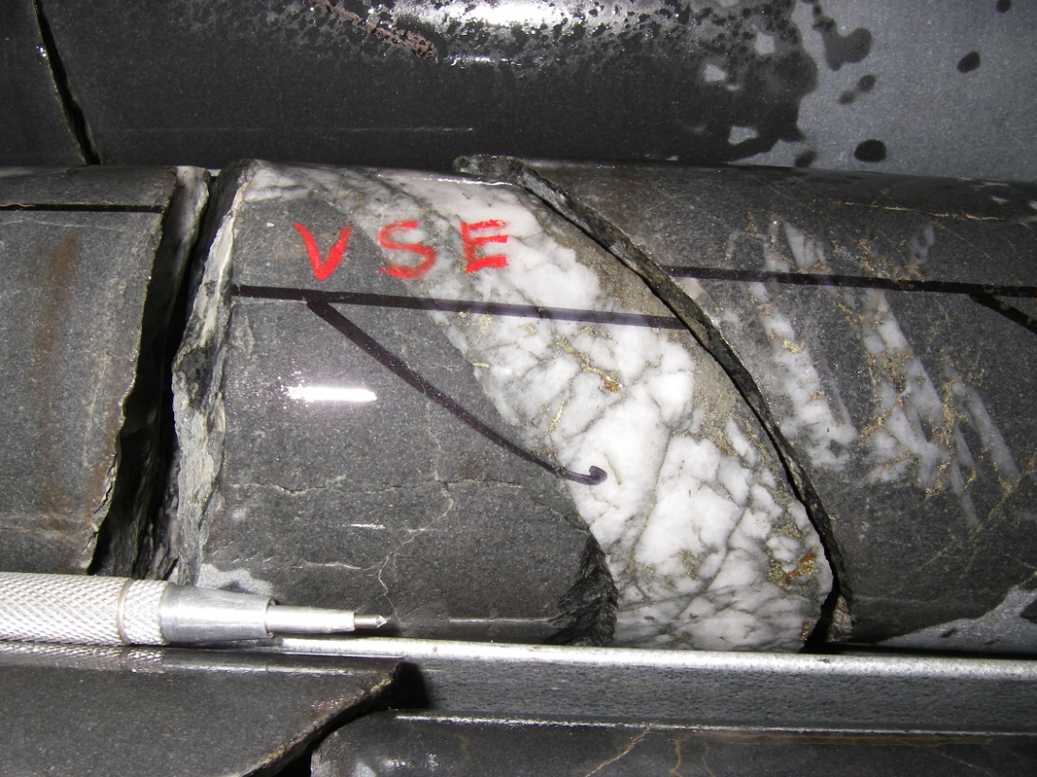

VA: Veins with silica sericite "wash" usually has a good selvedge and no sulphides

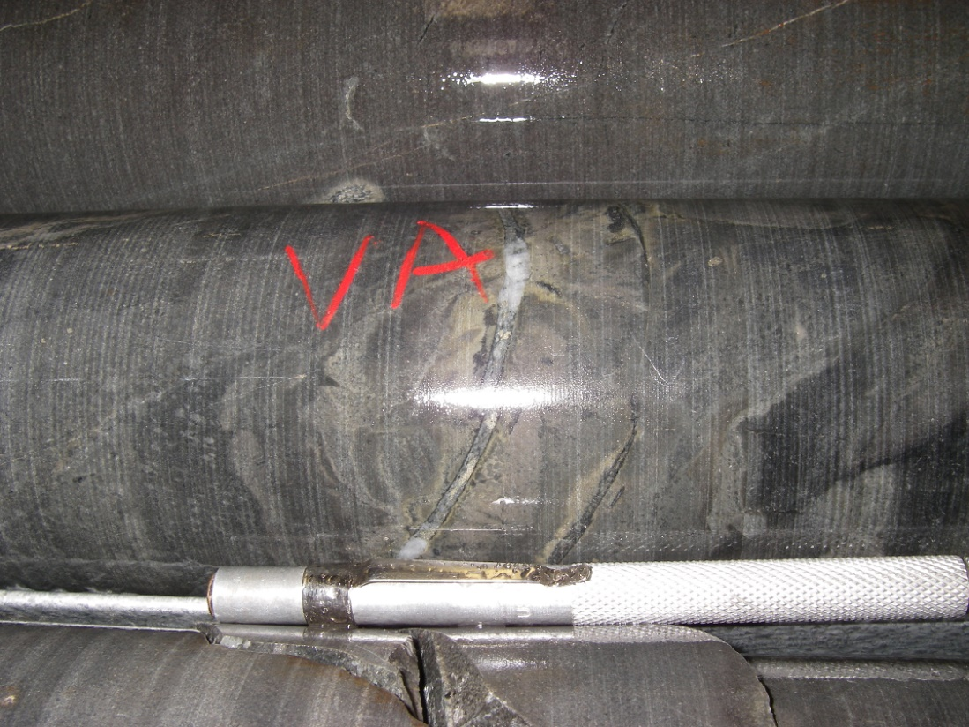

VB: Veins with silica sericite and sulphides

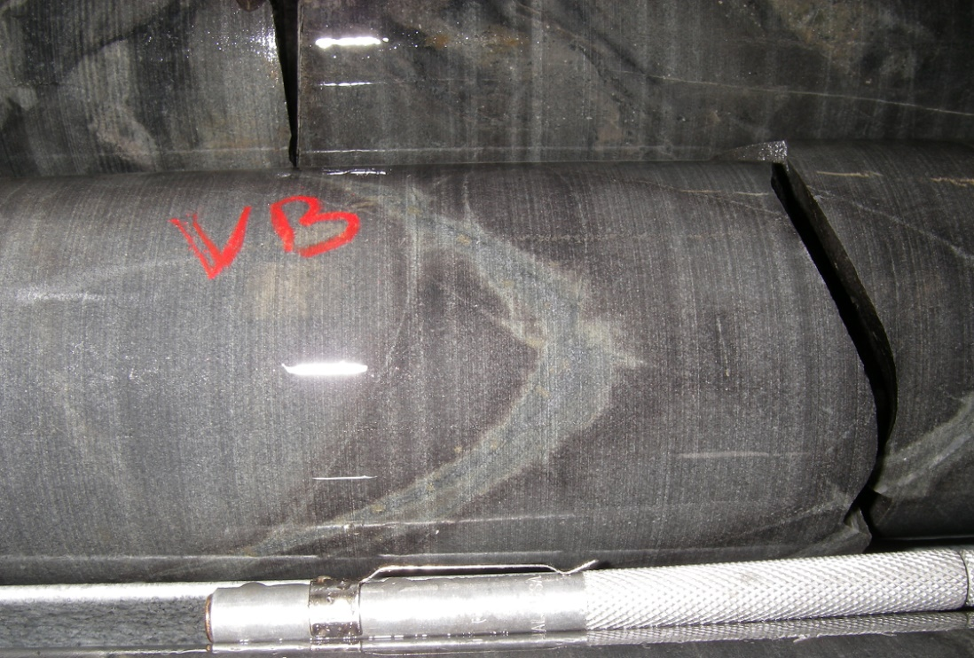

VQZ: Qtz veins, no sulphides

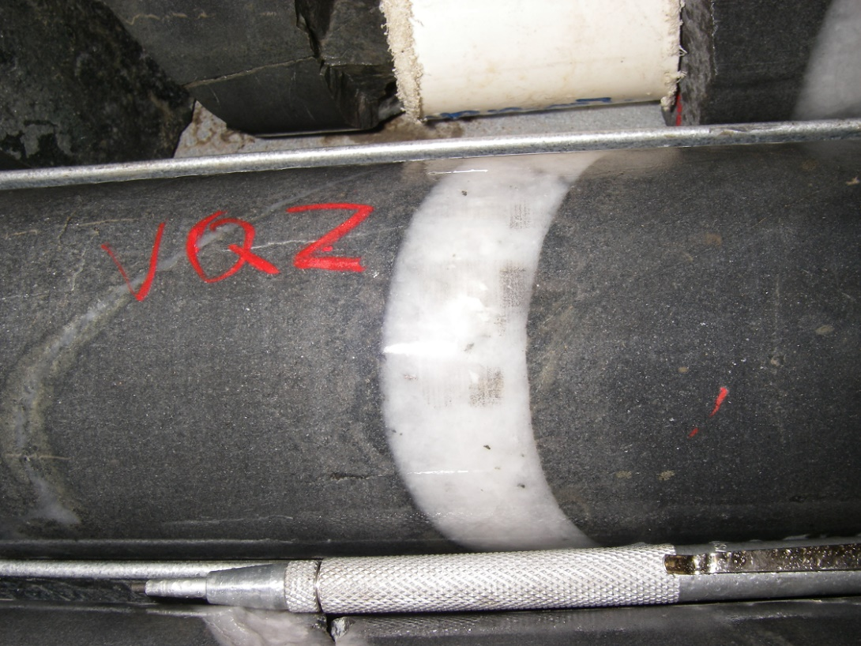

CARBONATE VEINS:

VCB: Carbonate veins, no sulphides

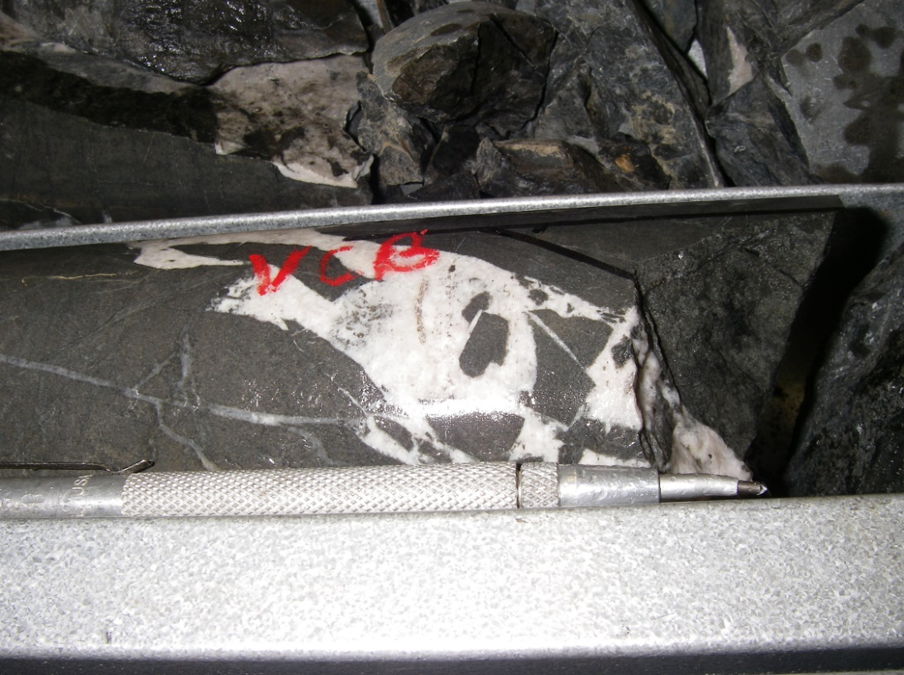

VCS: Carbonate veins, with sulphides

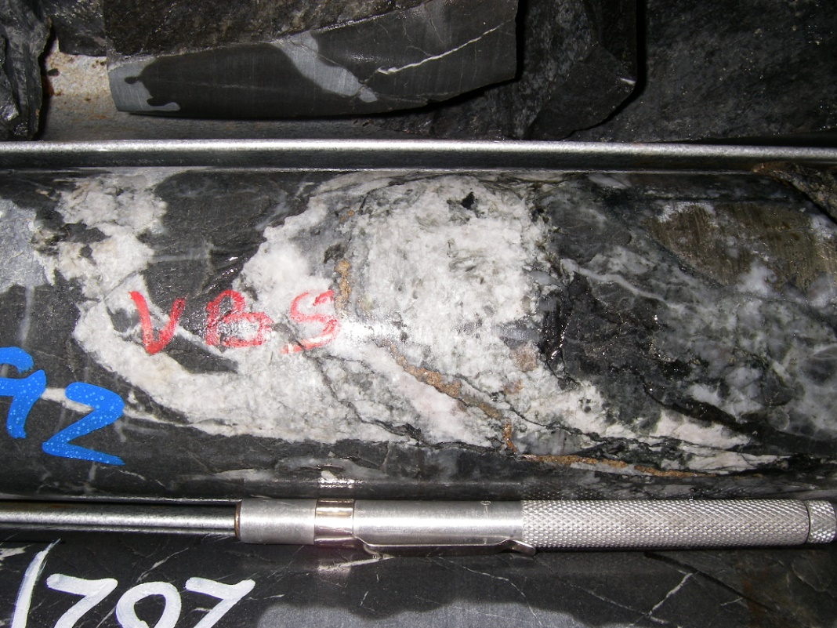

VSM and VSE veins appear to have follow a consistent orientation and are thought to host the majority of the mineralisation within Batman, they were initially all sampled as VS, selective sampling will determine which vein is the better mineralized. VCS veins have been seen on both the footwall and the hangingwall of the main mineralized ore shoot, these are possibly late expressions of the bounding structures controlling the main vein orientation. VA and VB veins appear to be late and may be related to a phyllic retrograde hydrothermal system driven by the intrusive identified in VB010-003.