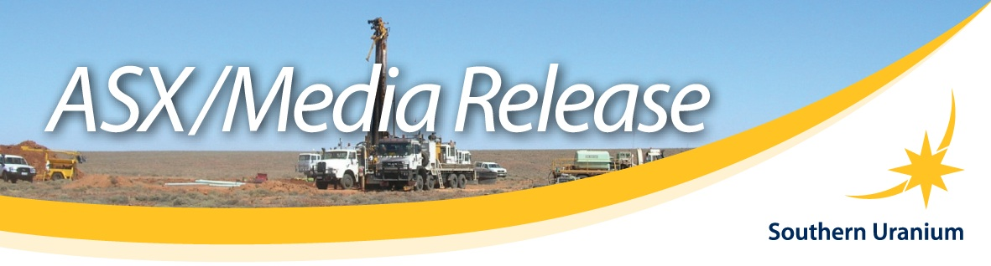

Date: 9th December 2009

Exciting vanadium discovery at Calvert Hills, NT

- Significant outcrops of vanadium and iron mineralisation have been discovered within the Calvert Hills joint venture tenement in the eastern Northern Territory.
- Rock outcrop sampling of haematite veined hydrothermal breccia averages 0.74% V₂O₅ (vanadium pentoxide) and 27.7% Fe (iron) over a 250m by 250m discovery area at the Vanadis prospect.
- Prospective breccia is mapped over wider 900m by 400m area.
- Portable XRF measurements show highly anomalous vanadium values along the entire 900m axis of breccia outcrop.
- Anomalous patterns in magnetic and satellite imagery indicate the mineralised breccia system may be developed over a 2km by 2km area.
- The discovery opens the potential for large mineral systems in a new vanadium province.
Southern Uranium Limited (ASX Code: SNU) and joint venture partner Crescent Gold Limited (ASX:CRE) have made a significant discovery of outcropping vanadium and iron mineralisation, now referred to as the Vanadis Prospect, in eastern Northern Territory.
The Managing Director of Southern Uranium, Mr John Anderson, said the Vanadis Prospect was located within the joint venture tenement EL 24837 in the Calvert Hills region (Figure 1) and had the potential to be a large mineralised system in a new vanadium province.
“This is an exciting development for the Calvert Hills exploration project where the joint venture is searching for Westmoreland-style uranium deposits at the base of the mafic Seigel Volcanics,” he said.
“The Vanadis Prospect has potential to be a large vanadium deposit. The vanadium values obtained from limited outcrop sampling to date are of the order of established vanadium resources such as Windimurra.”

Mr Anderson said the discovery had been made after recent drilling in collaboration with the Northern Territory Government had revealed that the Seigel Volcanics extended under cover into the central area of the tenement.
“A similar magnetic domain was investigated in the north east corner where we discovered the unmapped outcrops and vanadium mineralisation in an interpreted mafic intrusive complex” he said.
“The joint venture will not only evaluate the vanadium and iron ore potential of this very large mineralised system, but will also consider the conceptual potential of the geological setting for a range of metal targets including uranium, nickel, cobalt and platinoids.”
Vanadium is used as an additive to strengthen steel, in the production of aerospace titanium alloys, as a catalyst for production of maleic anhydride and sulphuric acid, in dyes and as target material for X-rays.
The previously unmapped outcrops of haematite veined hydrothermal breccia were located in the northeast corner of the tenement (Figure 2; Photos A-B).
Representative samples of outcrop exposures were collected by rock grab sampling within the 250m by 250m area of best developed outcrop (Figure 3). A total of 16 breccia samples have returned average values of 0.74% V₂O₅ and 27.7% Fe (Table 1; Figure 4A).
Mapping outlined semi-continuous rubble and outcrop of the breccia over an approximate area of 900m by 400m. Outcrop measurements taken with a portable XRF analyser were continuously and highly anomalous in vanadium along the 900m axis of the outcrop.
The north eastern boundary of the haematite breccia abuts a white brecciated host rock that is intensely altered by clay and silica (Photo C). The other outcrop margins pass under alluvial cover.
Magnetic and satellite imagery indicate the mineralised breccia system may be even larger with anomalous patterns identified over a 2km by 2km area (Figure 5).
Exploration under Calvert Hills EL 24837 is managed by Southern Uranium in Joint Venture with Uranium West Limited, a subsidiary of Crescent Gold Limited.
Both parties hold 50% interest with Southern Uranium earning to 75% by spending $400,000 on exploration by mid 2010.
For further information contact:  Mr John Anderson  Managing Director  Southern Uranium Limited  Phone: 07 3870 0357 | Richard Owen  Principal Consultant, Three Plus Pty Ltd  Phone: 07 3503 5700  Mobile: 0412-869-937

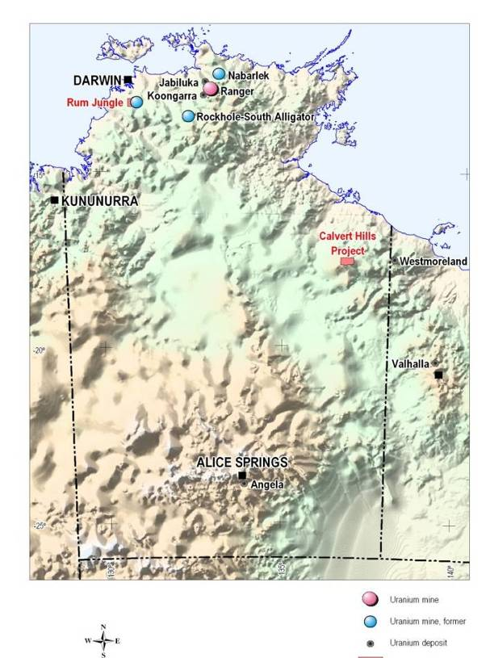
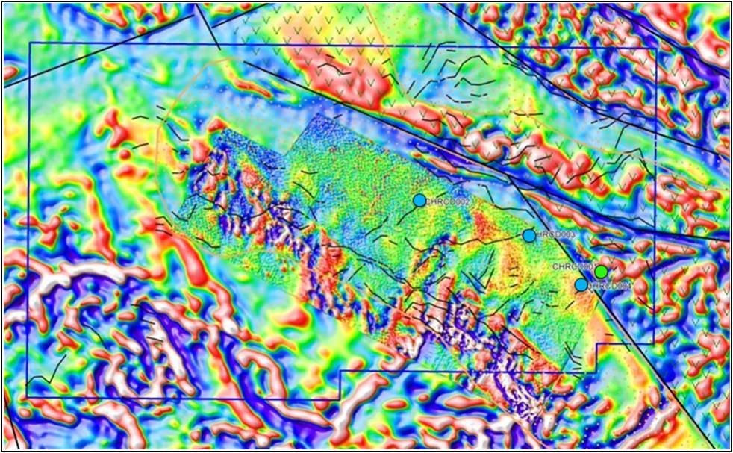
10km
Vanadis
Prospect
Figure 1: Location Plan –
Calvert Hills Project, Northern Territory

Figure 2: Location of Vanadis Prospect within EL24837, Calvert Hills Project
Underlying magnetic image is reduced to pole (RTP) first vertical derivative (1VD).
Interpreted fault structures are shown as black lines.
Location of recent diamond drilling coded for intersected geology Westmoreland Conglomerate
Seigel Volcanics

Figure 3: Outcrop and sampling plan – Vanadis Prospect
Rock grab sample locations are shown as infilled triangles.
Portable XRF measurement points are shown as dots.
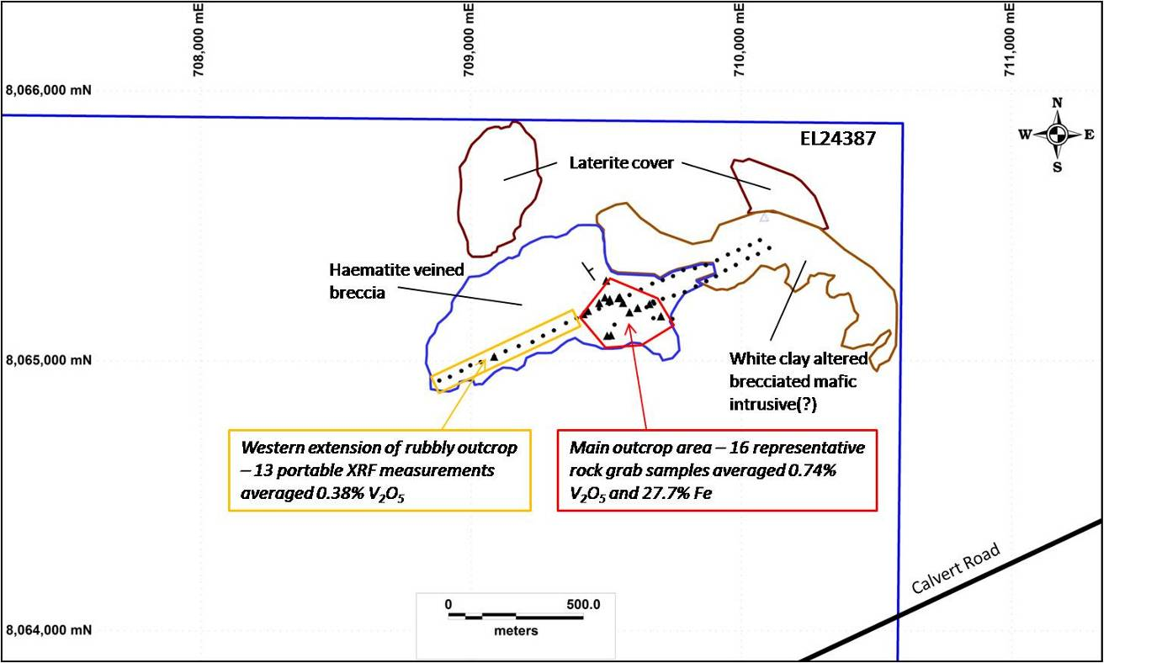

EL24837

Photo A: Typical low outcrop in the central haematite veined breccia area.
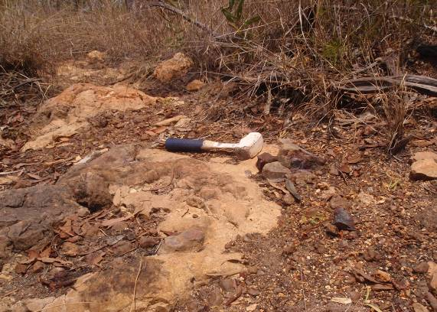
Photo B: Haematite stockworked and net veined, brecciated and altered host rock.
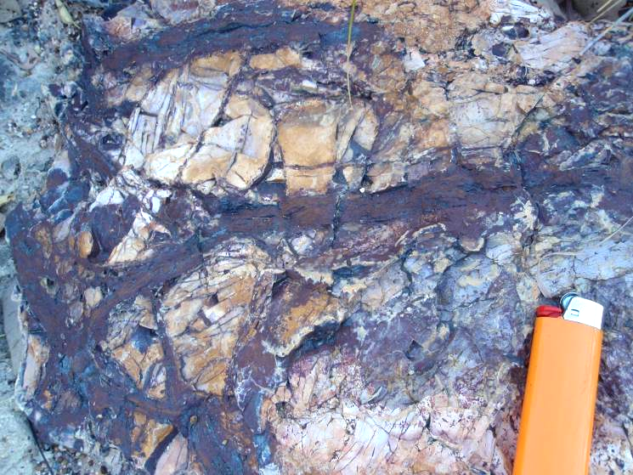
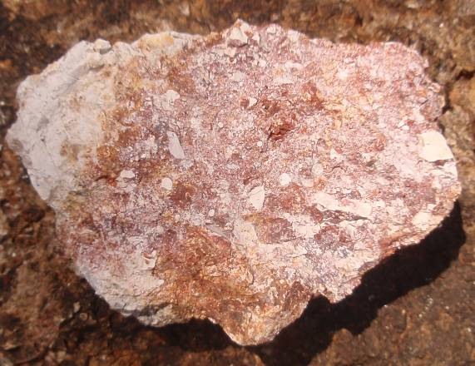
Photo C: Clay and silica altered brecciated host interpreted as a deformed mafic intrusive
Specimen is about 10cm across.

Table 1: Rock grab sample locations with iron (Fe) and vanadium (V) analyses
Comparison with Niton handheld XRF measurements for vanadium where
available at the same sample point.

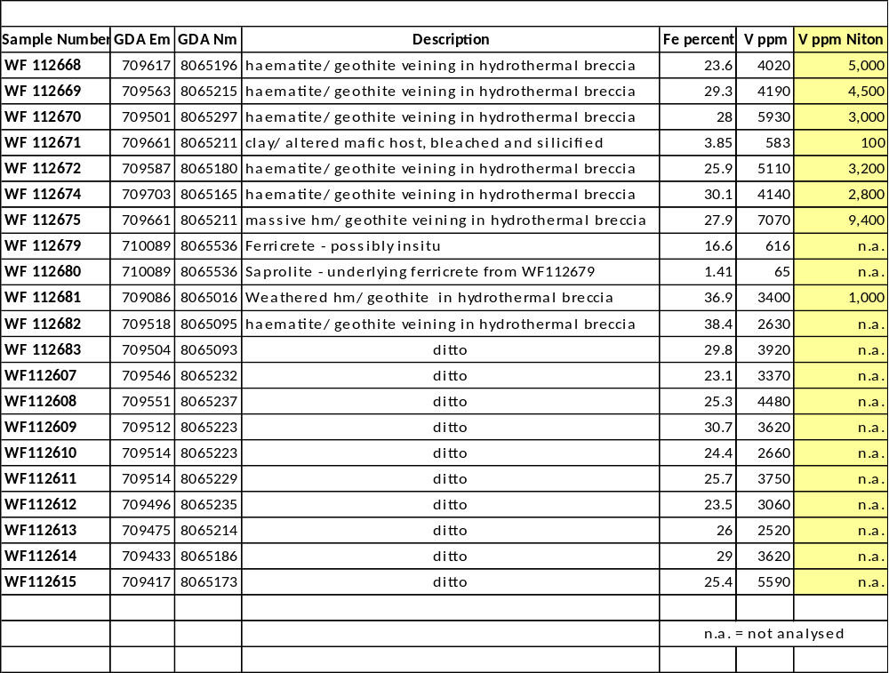

Geochemistry
The aim of the rock grab sampling was to obtain representative samples of the local outcrop exposures. About 2kg of rock sample was collected for each sample location. The accuracy of the rock grab sampling may be subject to bias by the preferential outcropping of resistant rock types and unintentional selective sampling. The rock samples were analysed by ALS Laboratory Group using the standard ICP-MS method; i.e. mass spectrometer measurement of an induced coupled plasma.
Sixteen samples of haematitic breccia collected in the main outcrop area averaged 4,158ppm V. This is equivalent to 7,400ppm or 0.74% V₂O₅. Grades of vanadium resources are usually quoted as V₂O₅. The conversion factor is V₂O₅ = 1.7852 x V.
A Niton XL3t was used for the handheld XRF analyses. It was set on soil mode, calibrated internally at the beginning of each sampling session and a standard measured every 10 to 20 measurements although the standard contained no vanadium and was therefore consistently measured as being below the limit of detection for that metal.
The XRF analyser measures with a small beam that makes representative measurement of outcrops difficult. The operator generally measured the haematitic veins. The rock grab samples were collected over a larger area that included the breccia matrix and are more representative of the outcrop exposure.
The similarity of the vanadium values at locations where both techniques were applied (Figure 4B) is therefore notable. For the eight comparative measurements, the Niton values are on average about 15% lower than the laboratory analysis for the rock grab sample at the same location.
Both types of analysis are considered consistent and relevant. The probable explanation for the similar results despite the different sample styles is that the vanadium minerals are disseminated through the brecciated matrix as well as the haematite veins. This is supported by the strong but non-linear correlation between iron and vanadium in the rock samples (Figure 4A). The highest vanadium values do not correlate with the highest iron values indicating the haematite veins are not the only host to the vanadium mineralisation.
Figure 4A: Graph comparing iron (Fe) and vanadium (V) values for each rock grab sample
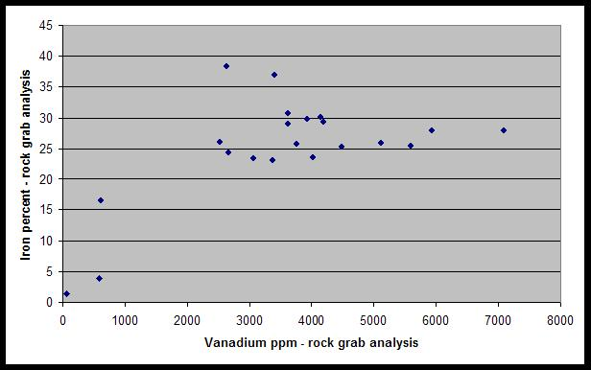
Figure 4A
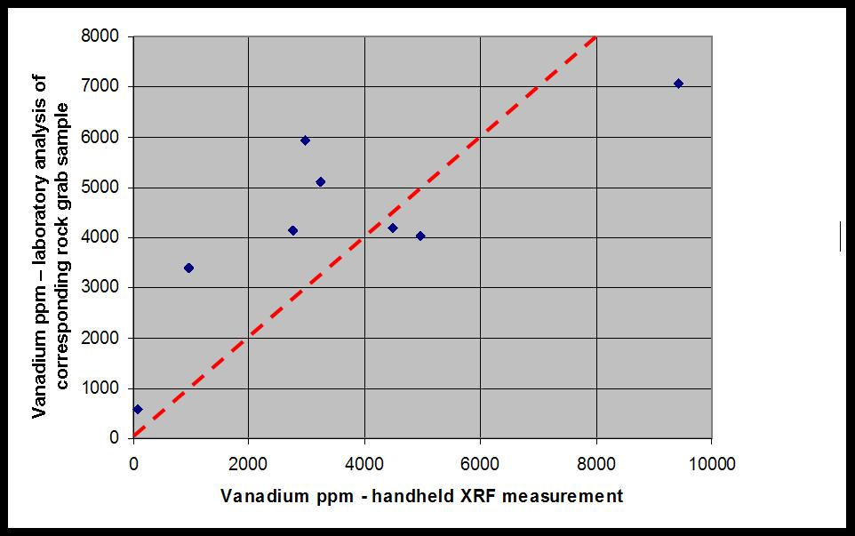
Figure 4B: Graph comparing vanadium analyses for rock grab samples with vanadium
measurements by handheld XRF where measured at the same sample points
The red dashed line represents a one-to-one correlation.

The portable XRF measurements of vanadium on the Vanadis outcrops are therefore considered reliable for prospecting purposes. This is particularly important for the measurements on the 600m traverse along the western extension of the outcrop axis from the main outcrop area. Thirteen Niton measurements at approximately 50m intervals average at 2,124ppm V or 0.38% V₂O₅. This may be an understated value as the only rock grab sample (WF112681) along the extension assayed 3,400ppm V in comparison with the Niton reading of 968ppm V at the same location.
Vanadium may be present at the Vanadis Prospect in association with disseminated sulphides and tellurides. Fine ex-sulphide casts are present in the weathered host rock and rare metallic inclusions are observed in quartz veinlets in a better preserved sample of the altered matrix. This interpretation is supported by consistently elevated silver (to 0.14 ppm), tellurium (to 0.94 ppm) and sulphur (to 0.11%) values in the rock analyses.
Target Potential of the Vanadis Prospect
The Vanadis Prospect has potential to be a large vanadium deposit. The vanadium values obtained from very limited outcrop sampling to date are of the order of established vanadium deposits.
For example the Windimurra deposit in West Australia has stated reserves of 97.8 million tonnes at 0.47% V₂O₅ (Reference- www.australianminesatlas.gov.au/aimr/commodity/vanadium_09.jsp ).
However the sampling and mapping to date at Vanadis are only investigating the two surface dimensions and the nature and grades at depth and the depth extent of the mineralisation can only be evaluated by drilling.
The high iron values will also be evaluated for a possible iron ore resource although the remote location would be a challenging environment for the mining and transport of a bulk commodity.
The anomalous outcrops are surrounded by cover of young drainage sediments. The area of mineralised outcrop and the anomalous sample traverse extends across a large airborne magnetic high with a modest peak amplitude of 100 nanoTeslas (nT) (Figure 5).
The magnetic anomaly strikes to the south east for about two kilometres. This is consistent with the shallow north easterly dip measured for preserved layering in the altered host. The magnetic anomaly is likely to be associated with the haematitic outcrops that may develop a magnetite component in the unweathered downdip extensions to the northeast.
Anomalous signatures in Landsat imagery indicate the prospective haematite breccia outcrops further to the west and south of the outcrops mapped to date (Figure 5).
The mapped and projected extent of the vanadium mineralised breccia system is very encouraging for a substantial target.
A possible geological setting is an intrusive mafic system at the base of the Seigel Volcanics. The Proterozoic age and interpreted setting have conceptual prospectivity for a range of examples of deposits associated with mafic and associated ultramafic intrusive rocks.
Further mapping and sampling will be undertaken at the earliest opportunity with possible delays due to the approaching wet season. The Calvert Road passes within two kilometres of the Vanadis Prospect. This is a formed unsealed road that may provide access at times during the wet season.

Figure 5: Interpreted magnetic and alteration extensions to the Vanadis Prospect.
Magnetic image is reduced to pole (RTP) total magnetic intensity (TMI) from available government regional airborne magnetic surveys. Magnetic contours intervals are 20nT.
Outlines of outcrops and sample points are the same as shown as for Figure 3.
Dashed red outlines are anomalous Landsat responses similar to the response from the haematite veined breccia outcrop in the same spectral bands.

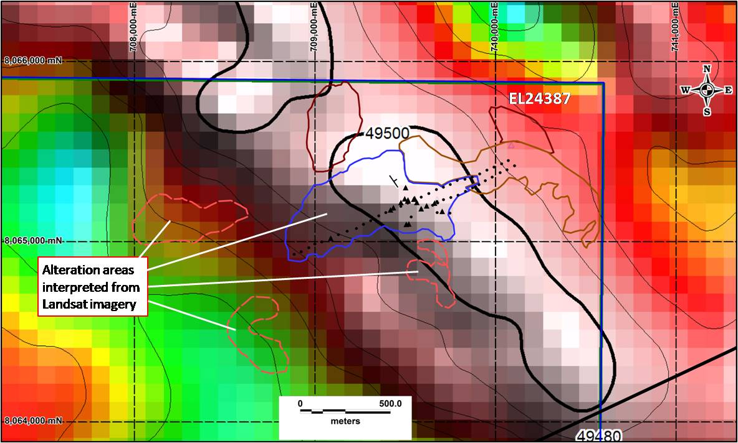
EL24837

Regional Potential
Reconnaissance sampling of rare and low outcrops have located vanadium anomalous rocks throughout the tenement area (Figure 6). Anomalous samples are often associated with magnetic anomalies along northwest structures that dominate the magnetic patterns.
The added evidence of extensive mineralisation in possible intrusive complexes demonstrates the Calvert Hills joint venture has discovered a new vanadium province within its tenement area.

Figure 6: Reconnaissance rock sampling and V analyses within EL24837 Calvert Hills
Underlying magnetics image is RTP TMI. Sample locations with laboratory analyses greater than 500ppm V are shown as large dots. A selection of potential vanadium targets and mafic intrusive complexes shown in red circles.

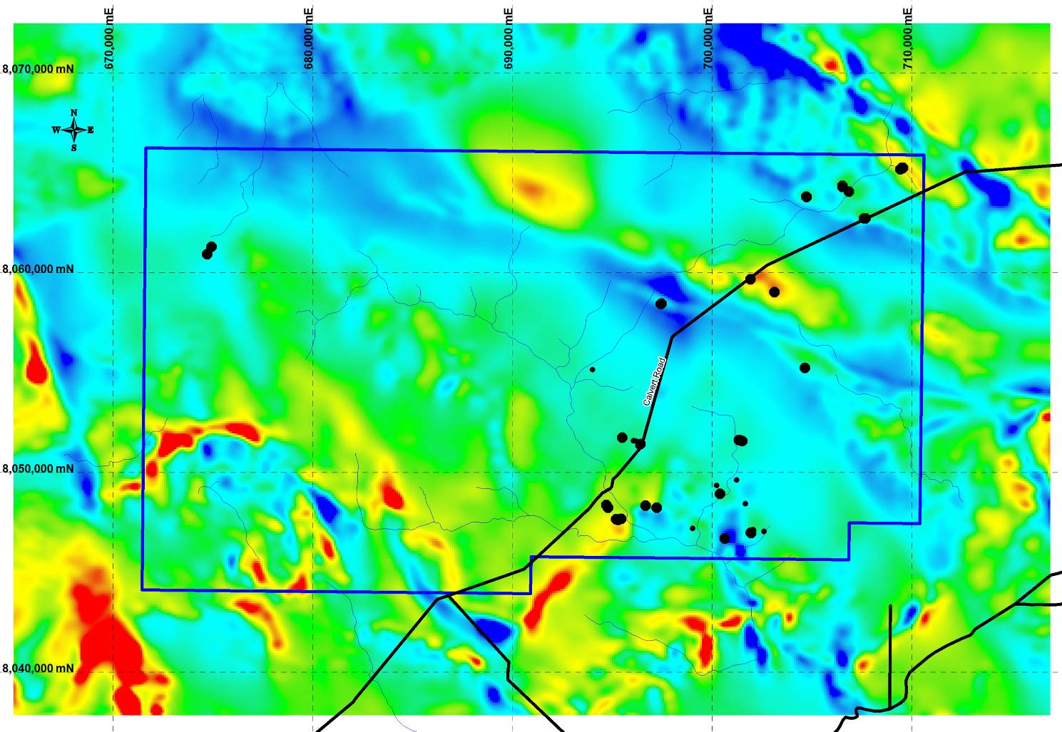

Vanadis
Prospect

Competent Person Statement: The information in this report that relates to Exploration Results and Mineral Resources is based on information compiled by John Anderson (BSc(Hons)Geol) who is a member of the Australasian Institute of Mining and Metallurgy and is bound by and follows the Institute’s codes and recommended practices. Mr Anderson is a full-time employee of Southern Uranium Limited. He has sufficient experience which is relevant to the styles of mineralisation and types of deposits under consideration and to the activities being undertaken to qualify as a Competent Person as defined in the 2004 Edition of the “Australasian Code for Reporting of Exploration Results, Mineral Resources and Ore Reserves”. Mr. Anderson consents to the inclusion in the report of the matters based on his information in the form and context in which it appears.

Southern Uranium Limited is a uranium, copper and gold focussed resources company with a strong platform of active exploration properties and drill targets in pedigree belts of Australia.
The Company aims to grow into a major explorer and developer by discovering new large resources that will compete for the anticipated shortfalls in global supply.

